Case Study 3: Retail Billing with Discount

1. Problem Statement
Calculate the total cost of a purchase and give a 10% discount when the total is ₹1000 or more.

2. Objectives
- Calculate total cost.
- Apply a discount if the condition is met.

3. Assumptions
- Quantity and price must be non-negative.
- Discount is 10% for totals of ₹1000 or more.

4. Algorithm
1. Read product price and quantity.
2. Calculate total = price * quantity.
3. If total >= 1000, calculate 10% discount.
4. Subtract discount and display final amount.

5. Flowchart
START → Input price and quantity → Calculate total → Check ₹1000 threshold → Apply discount if eligible → Display final amount → STOP
For a drawn flowchart, use: oval for START/STOP, parallelogram for input/output, rectangle for calculations, and diamond for decisions.

6. Pseudocode
READ price, quantity
total = price * quantity
IF total >= 1000: discount = total * 0.10
ELSE: discount = 0
final = total - discount
DISPLAY final

7. Python Source Code

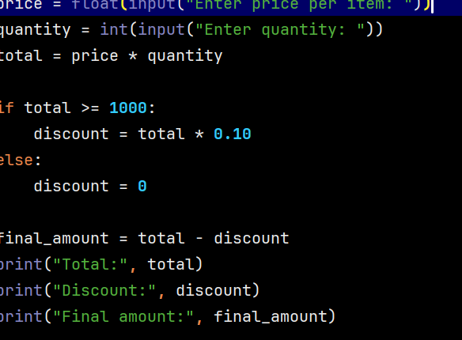 8.Test Cases
Test 1: price 250, quantity 4 → final ₹900. Test 2: price 100, quantity 2 → final ₹200.

Sample Output
Input: price ₹250, quantity 4
Output: Total: 1000.0
Discount: 100.0
Final amount: 900.0

9. Conclusion
The program demonstrates multiplication and a simple discount condition.

